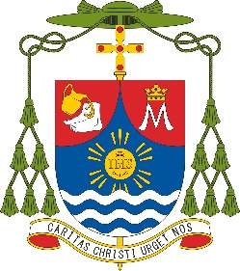

**Diocese of Aitape**

**OFFICE OF THE BISHOP**

**PO BOX 179, Aitape 553, Sandaun Province, Papua New Guinea**

**E-mail:** [**bpsibyhgn@gmail.com**](mailto:bpsibyhgn@gmail.com) **Cell: (+675) 70752851**

September 16, 2025

**To the Clergy, Religious, and Faithful of the Diocese of Aitape,**

On this joyful occasion of Papua New Guinea’s **50th Independence Anniversary**, I extend my heartfelt greetings to each of you and to all our brothers and sisters across the nation.

Today we lift our hearts in **thanksgiving to God** for the countless blessings of these fifty years. We remember with gratitude the leaders, elders, and ordinary citizens whose sacrifices and vision won us the gift of freedom.

This golden jubilee is a **time for celebration, not discouragement**. Challenges remain, but “there is a season for everything,” and this is the season to rejoice in the goodness of our people and the richness of our land.

Let us come together as **one country, one people—Papua New Guinea—united in hope and faith**, confident that the God who has guided us thus far will continue to lead us into a future filled with peace and promise.

With prayerful blessings,



✠Siby Mathew Peedikayil, HGN

Bishop of Aitape